**D1 - Explain the role of the TCP/IP protocol and how it links to application layer protocols**

**Introduction**

In this report, I will explain the role of the TCP/IP protocol and how it links to the application layer.

**Network Protocol**

It’s within a computer, a communication protocol is a system which plays a part of exchanging messages within or between the computer. The main protocols that are involved in the OSI layer is the following: HTTP, TCP, IP, TCP/IP and Hardware. They are many types of protocols, but these are the main and simple protocols that people should know.

**TCP/IP Protocol**

Application Layer makes the request to the other application you sent it to. HTTP is the common that any person would know. This stands for Hypertext Transfer Protocol. HTTP should take in response to any commands. For example, when you type in the URL the web page, it sends messages to the direct page for it to be done. Presentation Layer takes care of any issues that occur during the process. It only takes care of any data that is complete only in the application layer. This manages the compression and encryption. Session Layer manages to open, close and manage a session between the processes. In between the session layer, it has sockets. Sockets have two types, stream sockets and datagram sockets. Stream sockets is a type of internet socket that transmits data on a regular basis. Datagram sockets is a type of connectionless network socket, which is sending or receiving points – relating to session layer.

Transport Layer does all the transportation. TCP stands for Transmission Control Protocol. TCP is reliable, error-checked delivery from one point to another.

Figure 1.3

Internet Layer or IP layer is method that uses datagram to communicate through another network. It sends short messages. Each computer has its own unique IP address. It uses the IP routers to transmit data.

Network Interface Layer commonly refers to the data link layer. This receives the end package of the communication. This could include IEEE 802.2. The main aim of this layer is to provide trustable communication between the networks. This layer is important as it may cause security issues. One of the ways network interface layer does the data link is through Ethernet. Ethernet is a wire that commonly connects the computer to your router. It can connect Laptops to each other, so the internet connects perfectly.

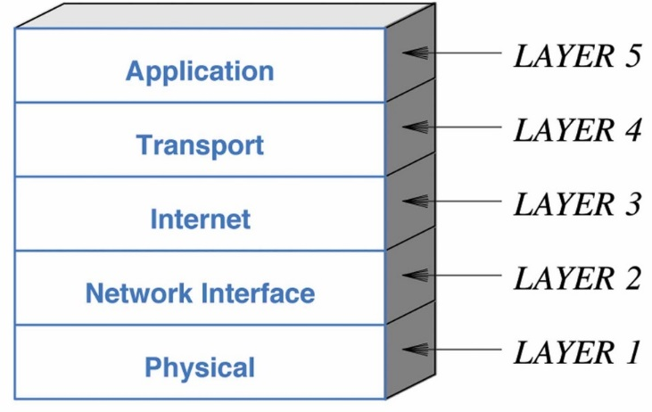Physical layer (layer 1) does the raw bits of all the communication throughout the layers. Physical aspects could be through wires, coax cable. Wirelessly communication could be slower as it sends signals, just like Bluetooth, to the other network and sends the data.

**Application Layer**

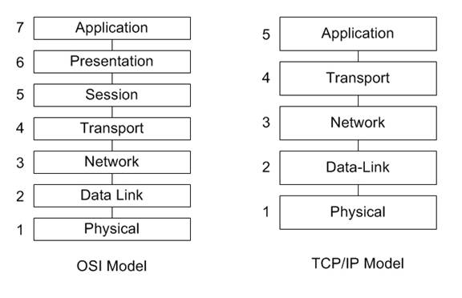Application Layer makes the request to the other application you sent it to. HTTP is the common that any person would know. This stands for Hypertext Transfer Protocol. HTTP should take in response to any commands. For example, when you type in the URL the web page, it sends messages to the direct page for it to be done.

**Transport Layer**

Transport Layer does all the transportation. TCP stands for Transmission Control Protocol. TCP is reliable, error-checked delivery from one point to another.

Figure 1.3

**Internet Layer**

Internet Layer or IP layer is method that uses datagram to communicate through another network. It sends short messages. Each computer has its own unique IP address. It uses the IP routers to transmit data.

**Reference**

**BTEC LEVEL 3 BOOK UNIT 9 CHAPTER**

* [**http://en.wikipedia.org/wiki/Protocol_(computing)**](http://en.wikipedia.org/wiki/Protocol_(computing))
* [**http://en.wikipedia.org/wiki/Hypertext_Transfer_Protocol**](http://en.wikipedia.org/wiki/Hypertext_Transfer_Protocol)
* [**http://www.hmailserver.com/documentation/latest/?page=whatis_pop3imapsmtp**](http://www.hmailserver.com/documentation/latest/?page=whatis_pop3imapsmtp)